|  |  |  |  |  |  |  |  |  |  |  |  |  |  |  |
| --- | --- | --- | --- | --- | --- | --- | --- | --- | --- | --- | --- | --- | --- | --- |
| **과제번호** |  |  | | | | | | | | | | | | |
| SW  융합교육원 | **산학 Capstone Design 결과 보고서** | | | | | | | | | | |  | | |
| **Project type** | ■애로기술해결형 | | | | | | □문제발굴형 | | | | | | | |
| **Project area** | ■AI | □Security | | | □VR/AR | | | □IoT | | | | | | □Bigdata |
| **Project Title** | Diet management application  for diabetic patients | | | | | | **Team name** | | | insulin | | | | |
| **Period** | September 2, 2017 ~ December 7, 2017 | | | | | | | | | | | | | |
| **Advisor**  **(Project manager)** | Belong | Dept of Undeclared-majors | | | | Name | | | Junho Choi | | | | | |
| Contact | 010-8611-9760 | | | | E-mail | | | xdman@chosun.ac.kr | | | | | |
| **Participating organizations** | Institution name | Comin  Information System | | | | Participating organizations  Practice | | | Department / Position | | | | Information Technology Research Institute/director | |
| representative | Shin Yongmin | | | | Name | | | | Lee Hyeongho | |
| **Participating students**  **(Including graduate students)** | Department (Major) | | grade | Student ID | | Name | | | | | Contact | | | |
| Computer Engineering | | 4 | 20124887 | | Hyeseon Jung | | | | | 010-4945-0724 | | | |
| Computer Engineering | | 4 | 20114760 | | Jaeun Choi | | | | | 010-3435-5529 | | | |
| Computer Engineering | | 4 | 20124879 | | Gyeongseo Kim | | | | | 010-3228-9221 | | | |
| Computer Engineering | | 4 | 20124930 | | Chohui Kim | | | | | 010-7255-6934 | | | |
| Computer Engineering | | 4 | 20144726 | | Yuseok Oh | | | | | 010-2672-4799 | | | |
|  | |  |  | |  | | | | |  | | | |
|  | |  |  | |  | | | | |  | | | |
|  | |  |  | |  | | | | |  | | | |
|  | |  |  | |  | | | | |  | | | |
|  | |  |  | |  | | | | |  | | | |
| Support project of Chosun University SW-centered university  We submit result report according to industry-academia capstone design support plan.  December 7, 2017  Professor : Junho Choi (인)  Representative student : Hyeseon Jung (인) | | | | | | | | | | | | | | |
| **조선대학교 SW융합교육원장 귀하** | | | | | | | | | | | | | | |

**1. Project Outline**

1.1. Task summary

[Figure 1] National Statistical Office: Number of diabetic patients by age



Diabetes does not play a role in insulin, glucose in the blood can not be absorbed into the cells, and if left in the blood as it becomes hyperglycemic state, if it continues to become diabetes. Foods such as carbohydrates, such as rice and bread, fruits and candy, are the main sources of energy for saccharides, which can be used as energy sources for the body or to aid in brain activity, but in diabetic patients, overdosing them can pose health risks.

In the data shown in [Figure 1], diabetes is a disease seen in various ages, especially patients in their 40s to 60s.

Therefore, it provides diabetes management application for diabetics who can not systematically manage their diets, and provides the function of inputting blood sugar to the patients and managing diets. When a user takes a picture of a food they eat, information about the food is displayed through image recognition using the tensor flow and the learned inception v3 model.

Basically, it is a dietary management application, so it can be used by people who are not diabetics. By using the automatic input method using the photographs rather than the manual input like the existing application, the user's time can be shortened and can be used more easily.

1.2. Members and Role

|  |  |  |  |  |
| --- | --- | --- | --- | --- |
| No. | Department | Name | Role | Participation(%) |
| 1 | 컴퓨터공학과 | 정혜선 | 총괄 |  |
| 2 | 컴퓨터공학과 | 최자은 | AI |  |
| 3 | 컴퓨터공학과 | 김경서 | Anroid |  |
| 4 | 컴퓨터공학과 | 김초희 | AI |  |
| 5 | 컴퓨터공학과 | 오유석 | Android |  |

[Table 1] Members and Role

1.3. Weekly tasks performed

|  |  |  |  |
| --- | --- | --- | --- |
| week | Assignment contents | Participation in company / institution | Participating Agency Name |
| 1 | Background survey for project ideas |  |  |
| 2 | Topic selection |  |  |
| 3 | Data Survey  (Diabetes, Machine Learning, Android, Server) |  |  |
| 4 | presentation |  |  |
| 5 | Data Survey  (Diabetes, Machine Learning, Android, Server) |  |  |
| 6 | Data Survey  (Diabetes, Machine Learning, Android, Server) |  |  |
| 7 | Android GUI configuration,  server implementation, DB implementation,  machine learning environment construction |  |  |
| 8 | Midterm presentation |  |  |
| 9 | Android GUI configuration,  server implementation, DB implementation,  machine learning environment construction |  |  |
| 10 | Android GUI configuration, server implementation, DB implementation,  Implementation of machine learning image recognition |  |  |
| 11 | Android GUI configuration, server implementation, DB implementation,  Implementation of machine learning image recognition |  |  |
| 12 | Full system implementation |  |  |
| 13 | Performance Evaluation and Experiment / Final Report |  |  |
| 14 | Performance Evaluation and Experiment / Final Report |  |  |
| 15 | final Report results |  |  |

[Table 2] Weekly tasks performed

**2. Project Result**

2.1 Project contents

[Figure 2] Existing applications

'Doctor Diary'



Existing applications require the user to enter the food they eat. It is troublesome to manually input each one, and if the user does not input all the information, it becomes difficult to grasp the exact numerical value, which may cause health care problems. Information on health-related foods can not be obtained from the application in [Figure 2]. To solve this hassle, the user takes a picture and saves it, analyzes the stored photographs, and grasps the food he or she has eaten.

[Figure 3]Diabetes management



Diabetes management is an application for dietary management, especially for people with diabetes. Two functions have been added. First, diabetic patients can use the application to manage their own blood sugar. Secondly, if you take the food you want to eat with the camera of the Android smartphone, you can get information about the food and food from the database through image recognition and display it on the screen. Of course, the user can eat at any time to see the diet. People with diabetes can find appropriate food, such as food to be eaten and food to avoid. Even if you are not a diabetic, you can use the app so that anyone who has a diet can use it.

2.2 Image recognition

[Figure 4] tensor flow



TensorFlow is an open source library from Google. The data flow graph is used, and the user can process various data such as image, voice, and video through the tensor flow. All images are classified into 1000 classes such as "Zebra", "Dalmatian", "Dishwasher" using Inception-v3 model that exists inside TensorFlow. When comparing the performance of the model, we examine the five predictions with the highest probability through the "top-5 error rate".

2.2.1 Preparing image data

[Figure 5] Food data

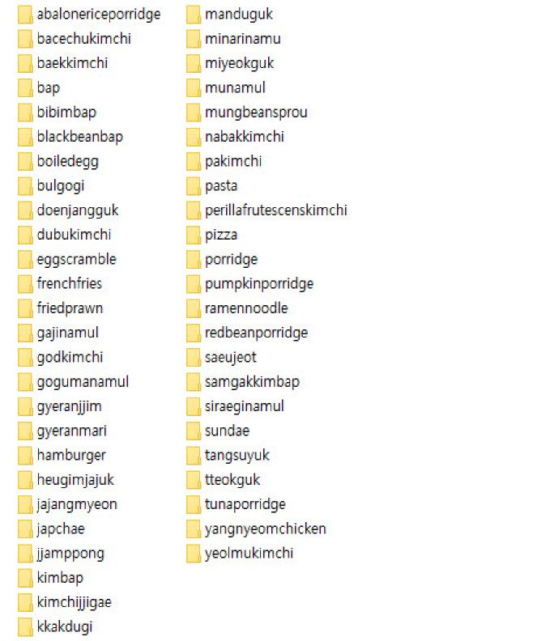

Create folders of different names in folders and store food pictures sorted. This folder structure becomes the label and sample image structure to be used for map learning.

2.2.2 Retraining inception-v3 models

[Figure 6] Tensor flow training

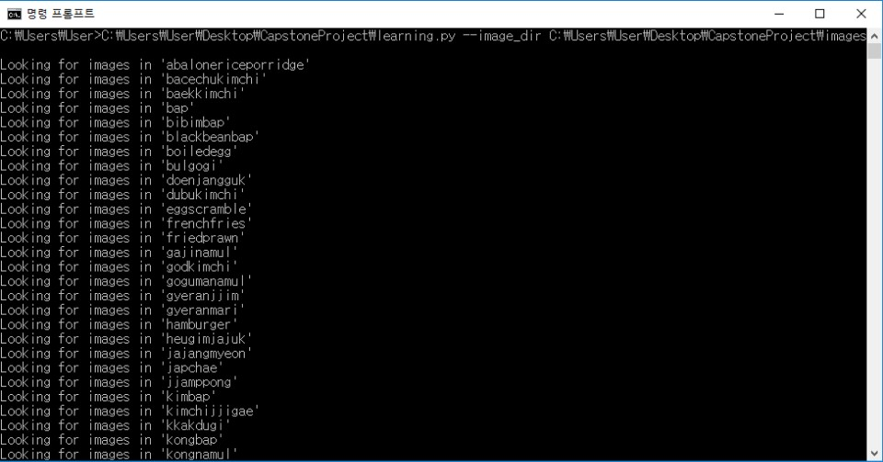

--bottleneck_dir

: Folder to convert and save the pictures to be learned: to compare with existing layer for classification (to be reused and speed up the next training).

--how_many_training_steps: Number of iterations.

--model_dir: path to download inception model.

--output_graph

: the learned binary file (.pb) to be used for inferencing storage path

(final learning result).

--output_labels: list of classification values.

--image_dir: Folder containing images to be learned.

[Figure 7] Training results

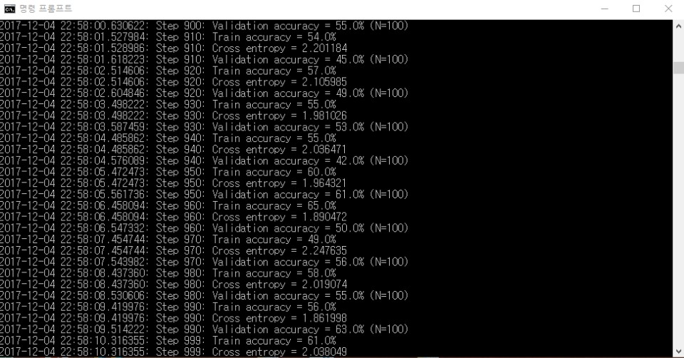

Train accuracy: Estimated accuracy of the training image compared to the learned images in the same label.

Validation accuracy: Estimated accuracy compared to randomly extracted learning images.

Cross entropy: Error rate (better the lower).

2.2.3 Image Reasoning

[Figure 8] test.jpg



[Figure 9] Recognition result



The most similar image to [Figure 8] is recognized as the highest 92% probability of kimch.

2.3 Android Application

[Figure 10] Figure Architecture

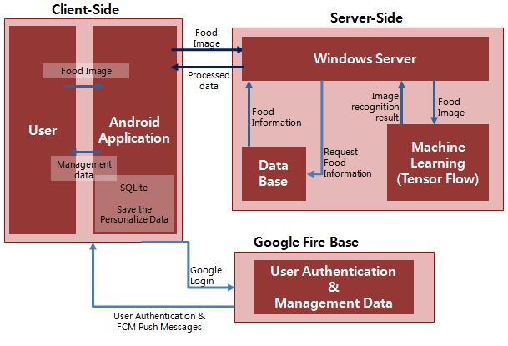

The user can access the application through google login. After connecting, user information is set up and food information, administration information is sent to the application. The application sends food pictures sent by the user to the Windows server and recognizes food pictures based on the machine learning data stored in the database. The application and the server communicate with each other using http, and the information resulting from the image recognition is transmitted back to the application. Finally, the user can get information about the desired food.

2.3.1 Login screen

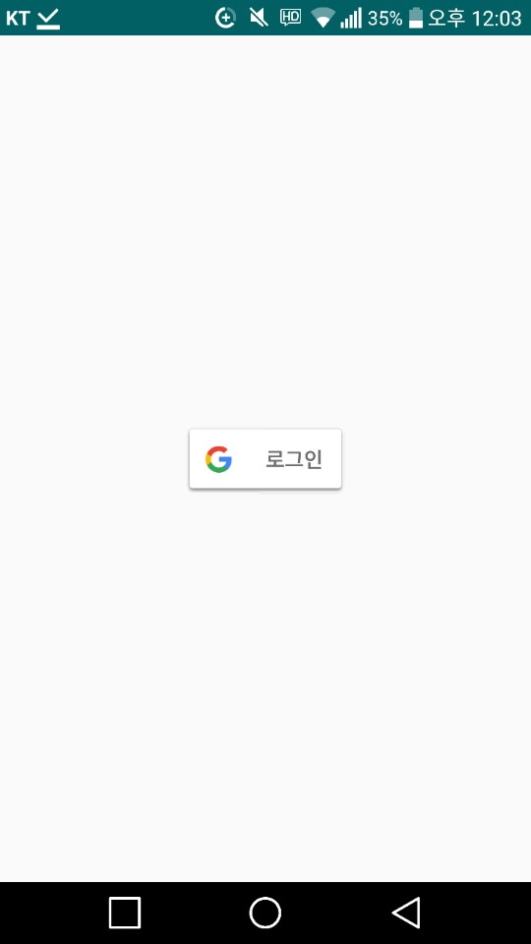 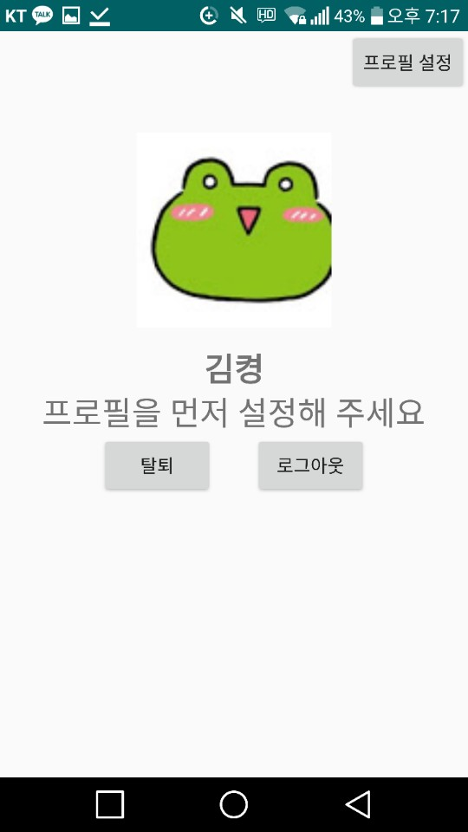 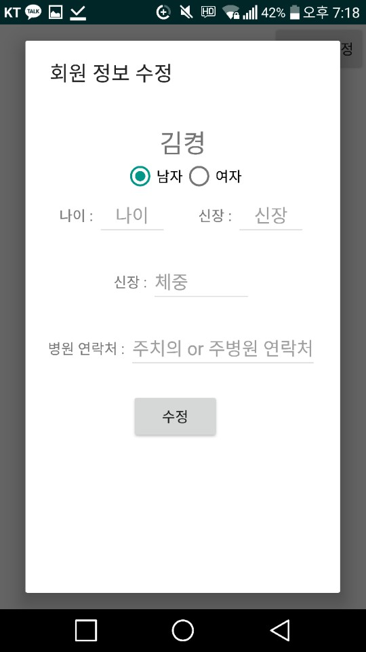

[Figure 11]

Google Login

[Figure 12]

Profile

[Figure 13]

Profile settings

After logging in with Google login, enter your body information through profile setting. Also, you can make a hospital reservation by dialing a phone number displayed on the main screen by setting up the contact information of the hospital that you frequently visit.

2.3.2 Food recognition

[Figure 14] Enter menu

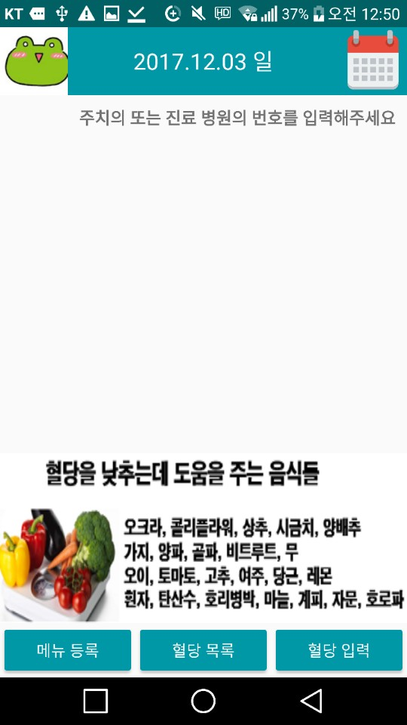 

[Figure 15] upload menu

[Figure 16] Recognition result

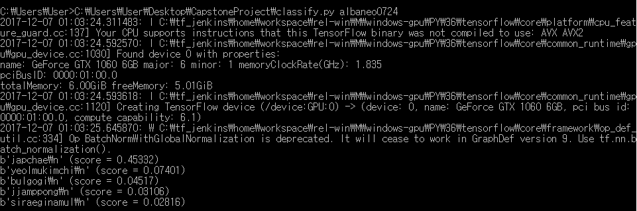

The food image can be recognized through the menu registration button. After checking the appropriate time during breakfast, lunch and dinner, use CAMERA and GALLERY to display the food pictures on the screen and upload them to the server by pressing the UPLOAD button.

2.3.3 Menu management

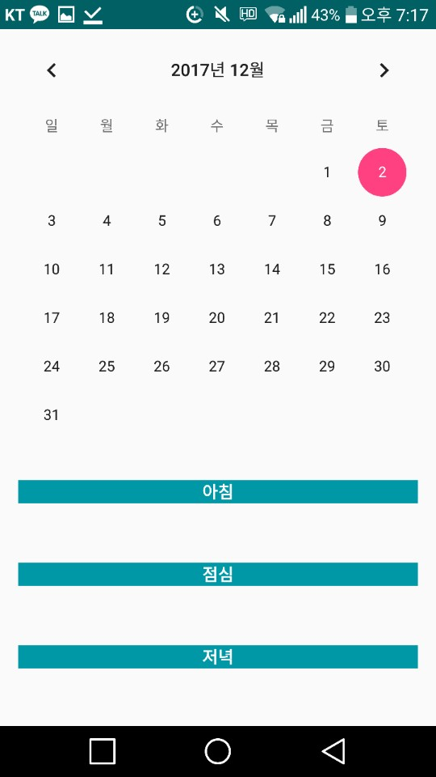

[Figure 17]

Menu management Screen

You can register breakfast, lunch, and dinner meals on any date. If you click on the date, the bottom view TextView shows the menu, so you can check the day at a glance.

2.3.4 Enter blood sugar

[Figure 18]

Enter

blood sugar

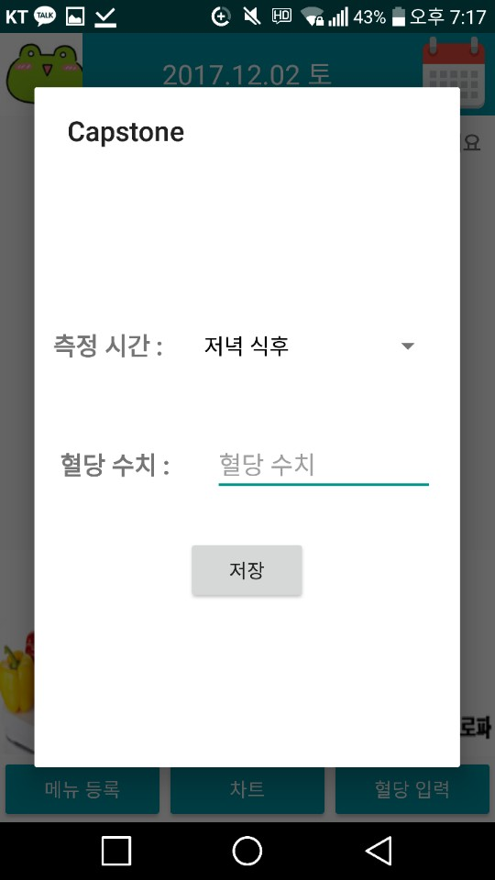

[Figure 19]

Blood sugar

management tip

The user's current date, time, and blood sugar levels are stored in the database after checking the time, meal, and meal after breakfast, lunch, and dinner. The stored blood sugar levels can be found on the blood sugar list.

2.3.5 Blood sugar List

[Figure 20]

Blood sugar List

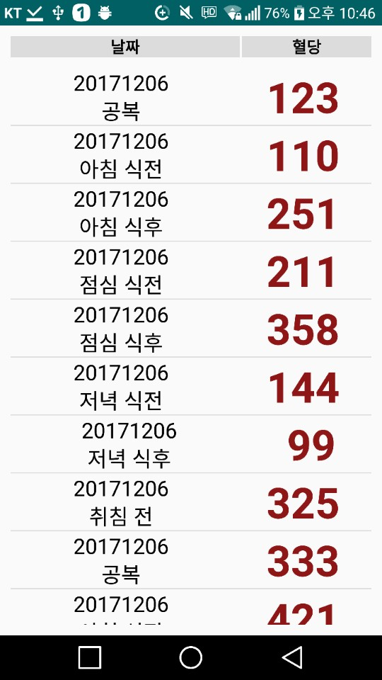

You can see the date, time, blood sugar stored in [Figure 19] in the list.

**3. process of project**

3.1 Idea derivation

Brainstorming gave chess, diet management, autonomous driving car, and a safe that opened with face recognition.

In particular, we have decided to create a dietary management application that can utilize image recognition and have high practicality. Especially, this subject is suitable for the purpose of production because it can combine the artificial intelligence technology that is attracting attention and can help the medical department.

3.2 system Architecture

[Figure 21] System Architecture



①The user connects to the application via google login and sends the data.

②The application sends the user a stored food photo.

③The server inferred the food from the photos that it received.

④The server sends the detailed information of the food corresponding to the inference result to the application.

(Applications and servers communicate with each other using http)

⑤And provides information received from the server to the user.

3.3 Collecting data

3.3.1 Data collection for image recognition

[Figure 22] collect Image



We collect about 200 photographs corresponding to food.

3.3.2 Materials for providing detailed food information

[Figure 23] Food datebase

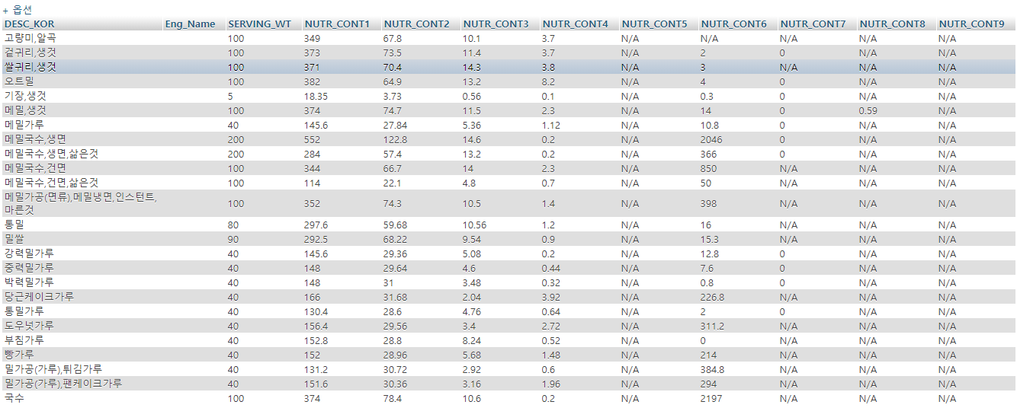

Collect detailed food information based on public goods data.

3.4 Android flow chart

3.4.1 Overall Flowchart (Login and profile settings)

[Figure 24] Flowchart (Login and profile settings)

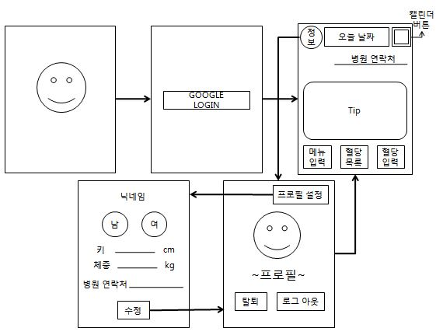

3.4.2 Overall Flowchart (Input blood sugar)

[Figure 25] Flowchart (Input blood sugar)

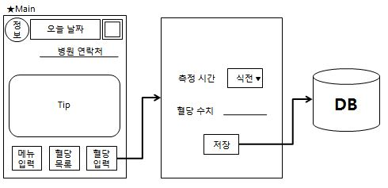

Save the blood sugar and time entered by the user in the DB.

3.4.3 Overall Flowchart (Blood sugar list)

[Figure 26] Flowchart (Blood sugar list)

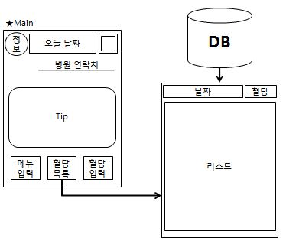

Click 'Blood sugar list' to display the time and blood sugar stored in the DB.

3.4.4 Overall Flowchart (Enter menu)

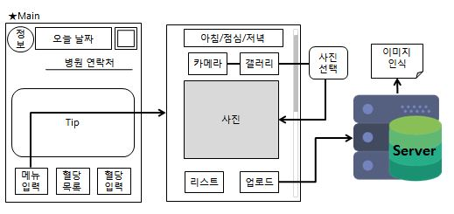

[Figure 27] Flowchart (Enter menu)

  The user saves the photo to the server, saves it, and analyzes the image.

3.4.5 Overall Flowchart (Calendars)

[Figure 28] Flowchart (Calendars)

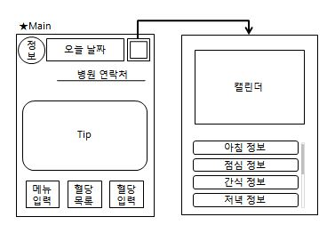

Pressing a date on the calendar lists the food information that you ate that day.

**3. Expected effects and utilization plan**

By providing calories per gram of food, it provides convenience for people who need weight control. Diabetics who need to limit their diets are informed about what foods should be restricted. The patient can decide whether or not to eat food directly with the information displayed on the application screen, and can prepare his own menu diary based on various information. You can check your health status from time to time by registering and checking blood sugar levels. It provides convenience to diabetics as well as users who need to restrict their diet. An application user can know the total calorie intake per day through the menu diary. These menu diaries can provide information directly on the screen for foods that are over-consumed or consumed, and the user can improve the unbalanced diet based on this information. With this application, you can create your own healthy and balanced diet.

**4. Whether or not the intellectual property right (patent, utility model, trademark, design, etc.) related to the subject matter**

|  |  |  |  |
| --- | --- | --- | --- |
| **intellectual property(Patent etc..)** | **Applicant** | **Filing date** | **Application number** |
|  |  |  |  |

**5. Whether the intellectual property application is planned**

|  |  |
| --- | --- |
| **Application plan agreement** | |
| □ Agree | □ Disagree |

**References**

Jae Jae Jong, "Do it! Android App Programming ", Easys Publishing

Jang Yong Sik, Seung Nak Hyun, "Step by Step Android Programming", Infinite Books

Kim, Sang Hyung, "Android Programming Conquering 1,2", Hanvit Media

Seo Chang-joon, "Making an Android App", Youngjin.com

Sam Abrahams, "Tensor Flow with Edge Explained", Hongreung Science Publishing Co.

Jordi Torres, "Ten Steps to the First Step", Hanbit Media

David Skla, Running PHP, Hanvit Media

https://www.gitbook.com/@tensorflowkorea

http://gusrb.tistory.com/16

https://developer.android.com/index.html

<http://recipes4dev.tistory.com/42>

<http://blog.naver.com/coocly/221077586786>

**Industry-Academic Capstone Design Project Summary**

|  |  |  |  |
| --- | --- | --- | --- |
| **Project Title** | Diet management application for diabetic patients | | |
| **Team Name** | insulin | | |
| **Advisor** | Junho Choi | | |
| **Participating students** | Hyeseon Jung, Jaeun Choi, Gyeongseo Kim, Chohui Kim, Yuseok Oh | **Intellectual**  **property rights** |  |

|  |
| --- |
| **Project Purpose** |
| A variety of new technologies are emerging in the 4th industrial revolution and the quality of life is increasing by combining these technologies and fields close to life.  Especially, it learns artificial intelligence (machine learning) and acquires related knowledge in preparation for the era of artificial intelligence that mankind has dreamed from the past. |

|  |
| --- |
| **Project Contents** |
| Existing applications require the user to enter the food they eat. It is troublesome to manually input each one, and if the user does not input all the information, it becomes difficult to grasp the exact numerical value, which may cause health care problems. Information about health-related foods can not be obtained from the above applications. To solve this hassle, the user takes a picture and saves it, analyzes the stored photographs, and grasps the food he or she has eaten. 'Diabetes management' is an application for dietary management, especially for diabetics. Two functions have been added. First, diabetic patients can use the application to manage their own blood sugar. Secondly, if you take the food you want to eat with the camera of the Android smartphone, you get information about the food and food from the database through image recognition. Of course, the user can eat at any time to see the diet. People with diabetes can find appropriate food, such as food to be eaten and food to avoid. Even if you are not a diabetic, you can use the app so that anyone who has a diet can use it. |

|  |
| --- |
| **Utilization plan and expectation effect** |
| It is an application that helps people who need to be aware of specific food intake and people who want to get information about food easily.   When you take a picture of the food you want to get information on, the app screen provides calories and simple information. It provides convenience for people who need weight control by providing food calories. It also provides information on which foods should be avoided for diabetics who need to limit their diets. The patient himself can decide whether or not to eat food directly by the information displayed on the app screen, and can prepare his own diary diary based on various information. The dietary diary allows the user to know the calorie intake, average calories, etc. during the day. These diary functions provide information on foods that have consumed too much or need to be consumed. Based on this, you can improve your unbalanced diet and create your own healthy and balanced diet. |